Agile wallaby (Macropus agilis) observations in Mission Beach (2013–14)

Executive summary
The Mission Beach region has historically had a resident population of the agile wallaby, Macropus agilis. Over recent years favourable conditions, a lack of predators, natural disasters and topography have led to a large increase in numbers in the area, in particular, residential South Mission Beach. As shown in Figure 1, South Mission Beach is located in an area surrounded by the Coral Sea, dense forest in the national parks (including the Hull River and Djiru National Parks) and the Hull River. The topography, vegetation and landscape surrounding South Mission Beach contributes to constraining the emigration of the agile wallabies from this area. This has resulted in an explosion in natural population numbers, raising community concerns over private property damage, road safety, human health and wellbeing and animal welfare.
The Department of Environment and Heritage Protection (EHP) became aware of the large population of agile wallabies at South Mission Beach in April 2013. Since then, EHP has conducted periodic counts of the agile wallaby population in different sections of the residential area of Mission Beach, South Mission Beach and Wongaling Beach and the surrounding small rural and agricultural properties (respectively the Mission Beach area and the surveys). The surveys were not intended to be exhaustive, simply informative. Their purpose was to provide information about the changes in the agile wallaby population over time for the purposes of wildlife management decisions. There was regularly a high variance of population numbers due to a wide variety of environmental factors and other limitations e.g. season, climate, survey time and accessibility to private property. It should be noted that the majority of information gathered was not representative of the actual number of agile wallabies in the region.

12 April 2013
- Information gathered between 13:00 and 14:00 in the residential area of South Mission Beach. Weather conditions were overcast and slightly drizzling. Approximately 400 agile wallabies were counted.

23 April 2013
- Information gathered between 17:00 and 18:00 in the residential area of South Mission Beach. Weather conditions were clear. Approximately 1200 agile wallabies were counted (Figure 2).

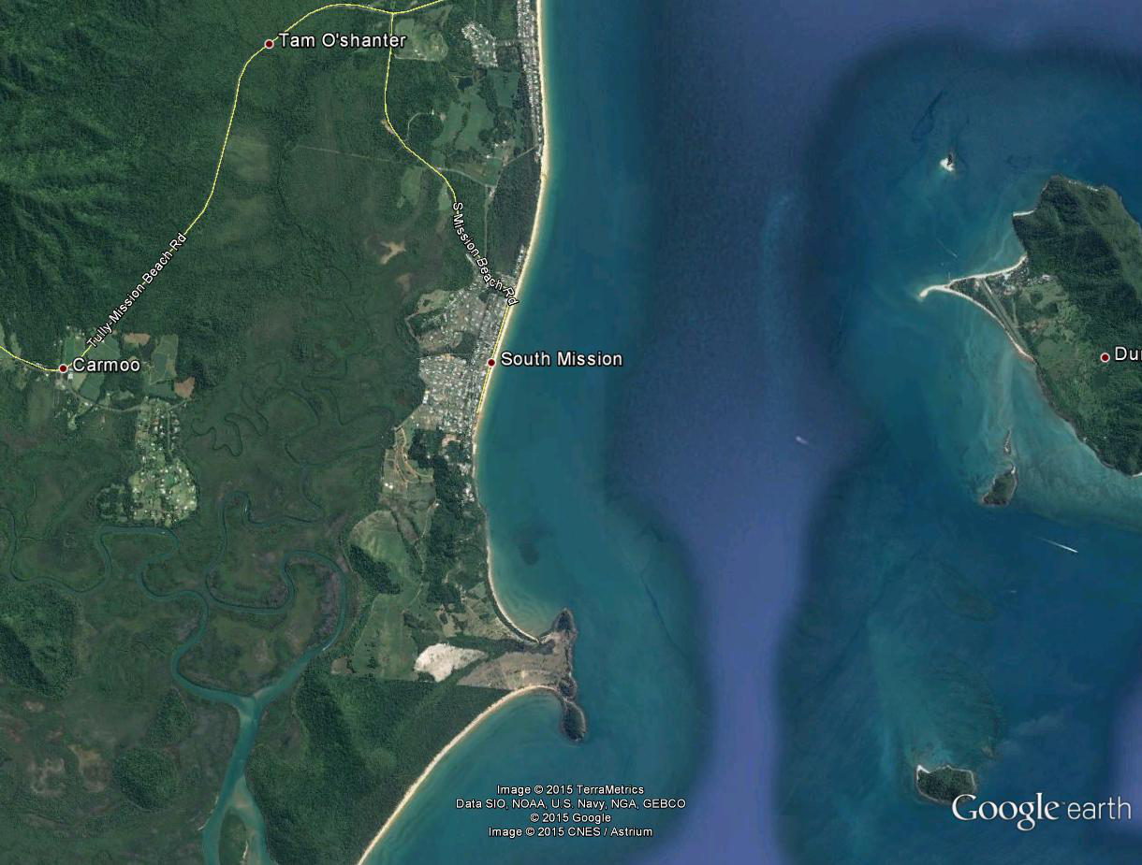
Figure 1: Google Earth image of South Mission Beach.
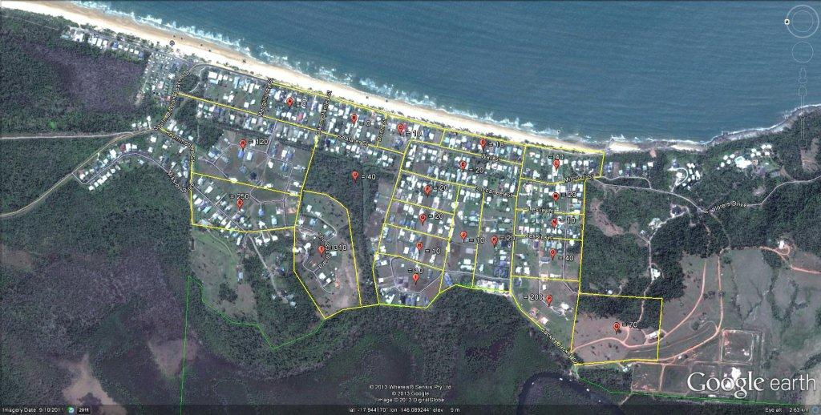Figure 2: Information gathered from count conducted on 23 April 2013 in the residential area of South Mission Beach.

15 January 2014
- Information gathered between 18:00 and 19:40 in the residential area of South Mission Beach.
- Weather conditions were approximately 26°C with low to moderate SE/E winds and 100% cloud cover. The agile wallaby population appeared to be in good condition, with a high number of juvenile wallabies present. Grass was plentiful and weeds were prolific in some areas due to recent rains.
- Approximately 655 agile wallabies were counted across the region—520 at South Mission Beach, 20 at Wongaling Beach and 115 at Mission Beach.

3 February 2014
- Information gathered between 11:30 and 13:00 in the residential area of South Mission Beach.
- Weather conditions were approximately 26°C with low to moderate SE/E winds and 100% cloud cover. The agile wallaby population appeared to be in good condition, with a high number of juvenile wallabies present. Grass was plentiful and weeds were prolific in some areas due to recent rains.
- Approximately 950 agile wallabies were counted.

16–17 April 2014
- Information gathered at South Mission Beach at 18:00 on 16 April and at 5:00 on 17 April in the Mission Beach region.
- Rural land South Mission Beach—approximately 560 individuals were counted (Figure 3).
- Residential South Mission Beach—approximately 450 individuals were counted (Figure 5).
- Rural land Mission Beach—approximately 460 were counted.
- Residential Mission Beach—approximately 190 individuals were counted ((Figure 4).
- Total in Mission Beach region—approximately 1660 were counted.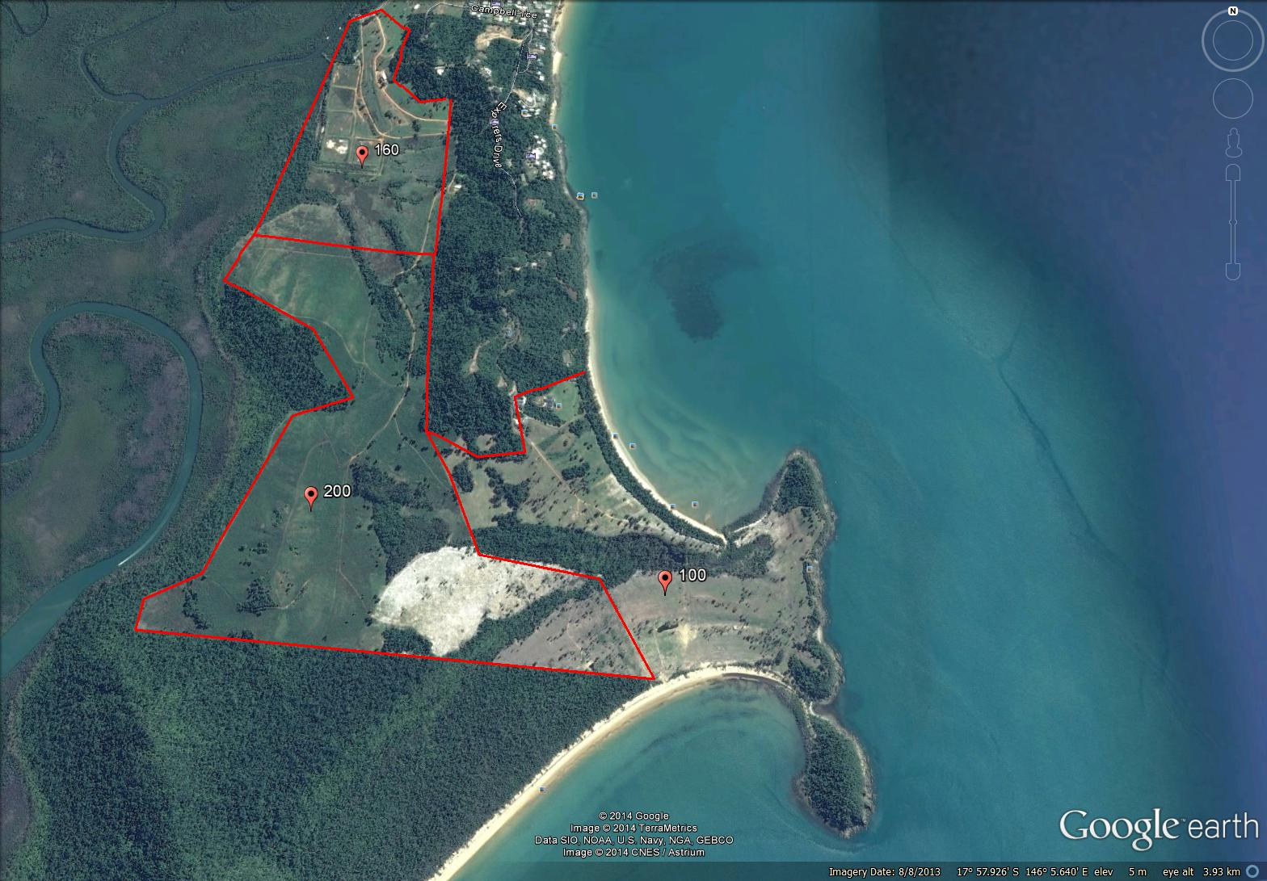
Figure 3: Information gathered from count conducted on 16–17 April 2014 in the rural area of South Mission Beach.
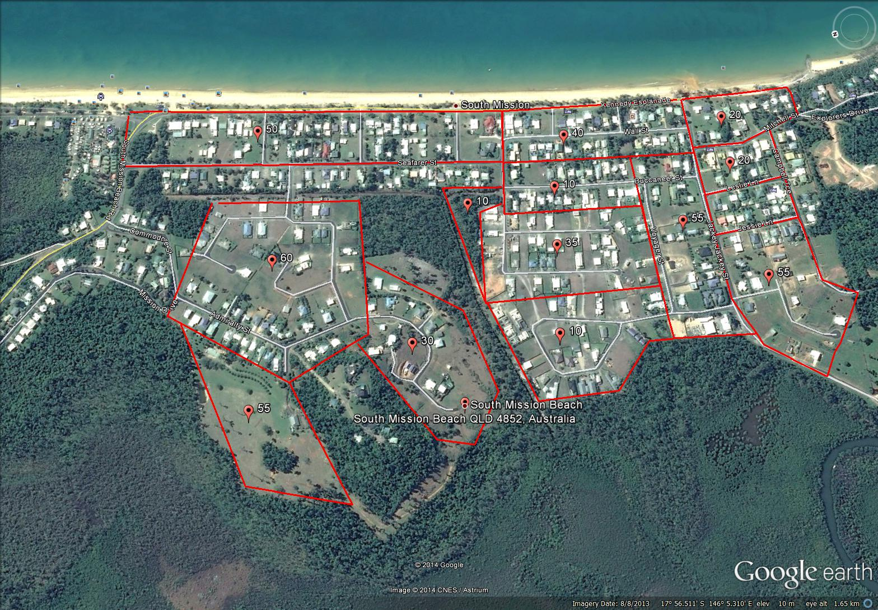
Figure 4: Information gathered from count conducted on 16–17 April 2014 in the residential area of South Mission Beach.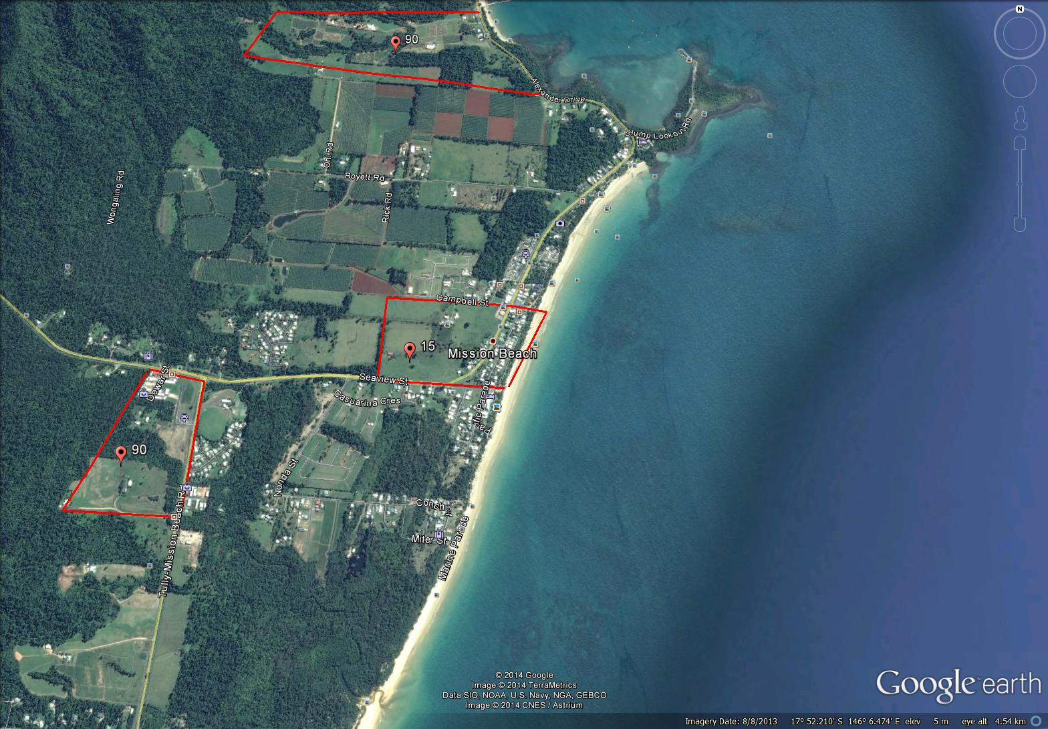
Figure 5: Information gathered from count conducted on 16–17 April 2014 in the residential area of Mission Beach.

8 July 2014
- Information gathered on 8 July 2014 between 4:00 and 6:00 in the rural and residential areas of Mission Beach and South Mission Beach.
- Weather conditions were 0% cloud cover, wind direction WNW at 6km/h, temperature of 10.3°C with a relative humidity of 96%.
- Approximately 120 individuals were counted in the residential area of Mission Beach and approximately 680 individuals in the rural region. Approximately 125 individuals were observed in the residential regions of South Mission Beach and approximately 750 were observed on rural land.
- Significant property damage was observed including large amounts of faecal matter, holes in the ground and prolific weed growth.

17–18 July 2014
- Information gathered on 17 July 2014 between 11:00 and 16:00 in the national park and reserve regions of the Mission Beach region.
- Weather conditions were: 0% cloud cover, wind direction WNW at 6km/h, temperature of 22.4°C with a relative humidity of 96%.
- The sampling methodology was a walked line transect. The sampling methodology used to count agile wallabies in the national park has been identified to estimate macropods that inhabit forested or mountainous country over large areas. Walked line transect method:
  - line transect 50m in length
  - count individuals within 25m of each side of the transect
  - two transects at each site, 200m apart.
  - five sites at South Mission Beach (Figure 6)
  - seven sites at Mission Beach (Figure 6)
  - three sites at Wongaling Beach (Figure 6).
- The line transect was 50m in length and two surveyors walked the line 50m apart, observing inwards only. The total sampled transect area was 2500m² and was replicated at each site approximately 200m apart to eliminate duplicate sightings. Sixteen sites were randomly selected and sampled across the Mission Beach region.
- Population estimates were calculated by dividing the total area by the sampled area. The total sampled area was then multiplied by the total mean of the transects. There is approximately 1,200,000m² of reserve land which is Dry Open Sclerophyll Forest/Woodlands in the Mission Beach region. The mean of the reserve area was 4.2 individuals in each walked line transect and it is therefore estimated that approximately 2016 agile wallabies inhabit the vacant reserve land.
- While no agile wallaby individuals were observed in the Rainforest or Mangrove Swamp Land habitats, there was wallaby faecal matter and flattened understory observed in the first 10m of the transect, suggesting that the wallabies may be using these locations to congregate.
- Between 15:15 and 16:00 EHP officers conducted a direct observation survey of the agile wallaby population in the residential region of South Mission Beach. Approximately 464 individuals were observed. An additional survey was conducted on 18 July between 08:30 and 09:15 and approximately 79 individuals were observed.
- It should be noted that the information gathered was not statistically analysed.

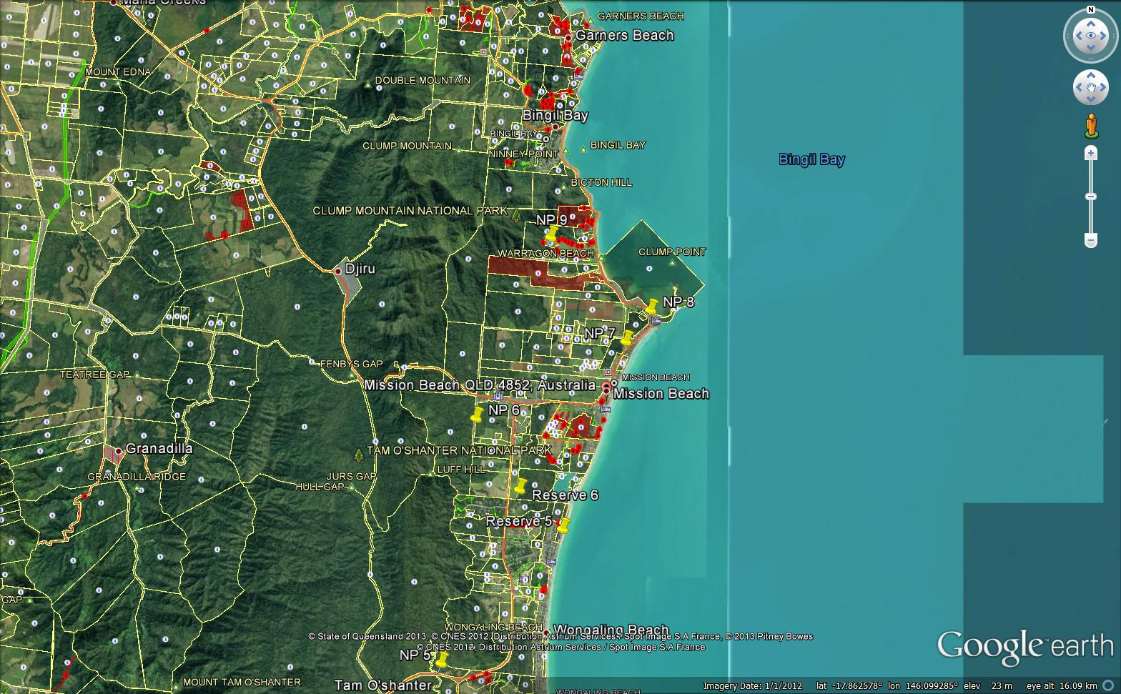
Figure 6: Information gathered from count conducted on 17 July 2014 in the Mission Beach region.

